Creating the Find Method
Accessing the Database with your code

Adding the Presentation Layer 1
Before you Begin 1
Start A Fresh Branch 1
Questions 3
Merge the Branch to the Master 3

Adding the Presentation Layer

Start A Fresh Branch
As always start with a clan folder, a fresh clone and new branch!

The final test of this functionality is to add a presentation layer to our work.
Previously you will have modified data entry form to include the following text fields…
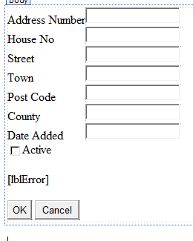
Modify the web form to include a button to execute the find operation…
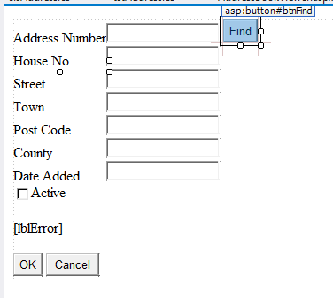
In this case the button would have an ID of btnFind and the text would be “Find”.
Double click the find button and add the following code…
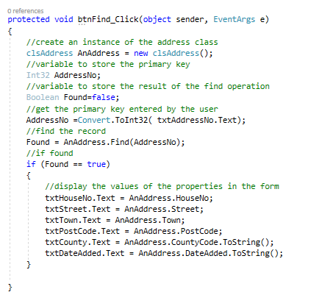
When you run the project, you should see this…
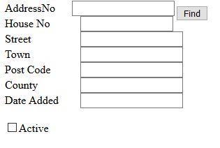
If you enter a valid primary key, you should see the data for that record displayed…
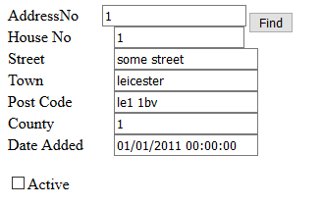

Questions
What happens if you enter a primary key value for a record that doesn’t exist?
How might you fix this to provide an error message?
What happens if you type a text value for the primary key?
Again, what it’s the problem and how might you fix this?

Merge the Branch to the Master
That’s enough work for one Git Hub day, remember to merge the code to the master and delete the branch.

